# Assignment 3 Skin Detection!

For this assignment I chose to utilize the RGB detection method outlined in the supplied text *A Survey on Pixel-Based Skin Color Detection Techniques.*  On the two sample photos. As predicted the detection method had a high accuracy with the “good” sample photo, and a more difficult time with the darker “dark” image. The RGB thresholding outlined in the paper falsely identified the background of the dark image as skin sample. Therefore we needed to utilize additional image processing methods to accurately extract the skin sample. The figures below are the original input images and the corresponding RGB detection results.

*

As we noted before we can observe that the RGB pixel detection alone really fails to isolate just the skin sample in our second source image. To more accurately extract the desire sample I utilized, as suggested, a histograph analysis of luminosity of the dark sample. Utilizing the CV color convert function, I converted the RGB filtered image into the LUV color space.

Once extracted, aggregate the histogram: A count of the number of pixels of the image at every luminance intensity 0-255. The graph of the results of the histogram shows we have two significant spikes in count of intensity. We can observe that these two spikes represent first the pixel of the skin sample and secondly the pixels found in the background. To eliminate the undesired pixels we need to find a threshold limit between the two maximums and “zero out” any pixels past that threshold luminosity. This can be achieved through the clever use of a convolution of the histogram to find where the greatest change from high to low to high occurs. This convolution then returns the “local minimum” and our useful luminance threshold. After which we simple scan back through the luminance component black out any pixel values over the threshold. Return that component to the LUV space image. Convert back to RGB and print the results. As can be seen in the following figures.

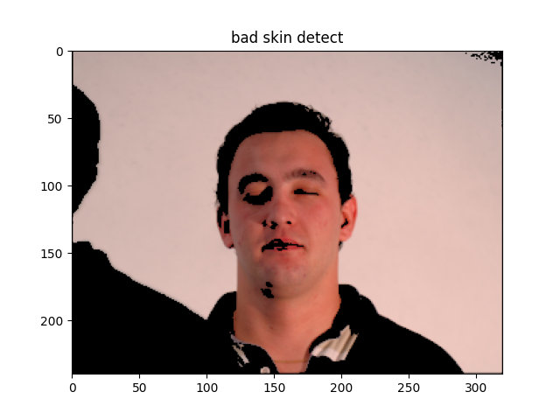

This project was thoroughly enjoyable exploring the histogram applications and better understanding the power of clever designing of convolutions. I was happy with the final results and look forward to learning more methods of image processing!